**ST. XAVIER’S COLLEGE**

(AFFILATED TO TRIBHUWAN UNIVERSITY)

MAITIGHAR, KATHMANDU



**COMPUTER NETWORK LAB ASSIGNMENT #5**

**SUBMITTED BY**

Pradeep Dahal

017BSCIT29

4th sem/ 2nd year

**SUBMITTED TO**

|  |  |  |
| --- | --- | --- |
|  | **Signature** | **Remarks** |
| **Mr. Sanjay Kumar Yadav**  **Lecturer, Dept. Of Computer Science** |  |  |

**OBJECTIVE: STATIC ROUTING CONFIGURATION**

**REQUIREMENTS:**

1. CISCO Packet Tracer
2. Switches
3. Router
4. End devices
5. Copper Straight-Through and Cross Over Cables

**THEORY:**

**Static Routing:** Static routing is a type of network routing technique, it is the manual configuration and selection of a network route, usually managed by the network administrator. Static routing is a type of network routing technique. Static routing is not a routing protocol; instead, it is the manual configuration and selection of a network route, usually managed by the network administrator.

Advantage of static routing

* It is easy to implement.
* It is most secure way of routing, since no information is shared with other routers.
* It puts no overhead on resources such as CPU or memory.

Disadvantage of static routing

* It is suitable only for small network.
* If a link fails it cannot reroute the traffic.

**PROCEDURE:**

Step 1: Start the packet tracer and select two routers, two switches, and end devices for each switch. Connect the routers, switches and end devices using parallel cables and crossover cables as per the requirement and create a LAN as shown below:

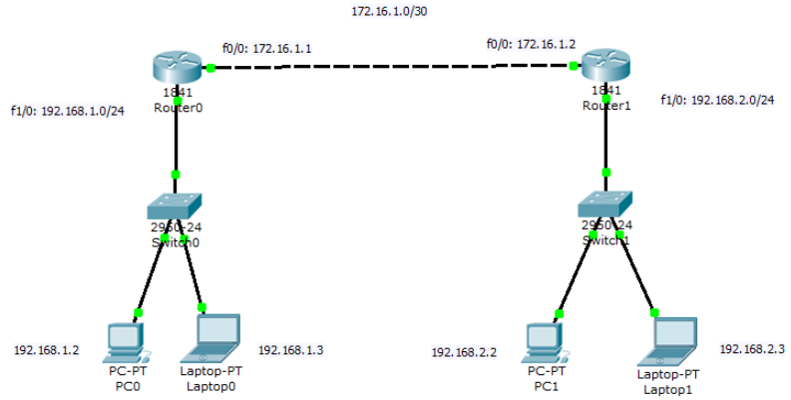

Step 2: Assign IP address to interfaces of routers.

A screenshot of a social media post

Description generated with very high confidenceFor router 0:

A screenshot of a social media post

Description generated with very high confidenceFor router 1:

Step 3: Configure Static Route

By default, when a packet arrives in interface, router checks destination filed in packet and compare it with routing table. If it finds a match for destination network, then it will forward that packet from related interface. If it does not find a match in routing table then it will discard that packet. This is the default behavior of router.

Run following command from global configuration mode in routers.

A screenshot of a cell phone

Description generated with high confidenceFor router 0:

A screenshot of a cell phone

Description generated with high confidenceFor router 1:

Step 4: Assign IP address to PCs or end devices either manually or automatically through DHCP routing as done in assignment 4.

Step 5: Send packets/messages from one PC to another.

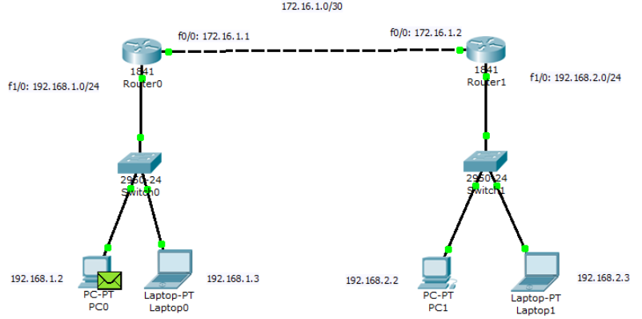

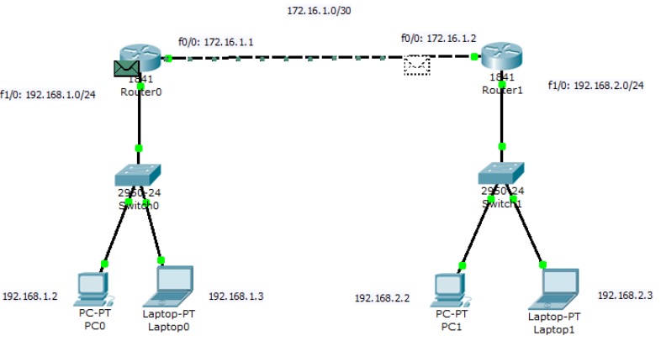

A screenshot of a video game

Description generated with high confidence

A screenshot of a video game

Description generated with high confidence

*Figure: Sending packets from one PC0 to PC1 and receiving acknowledgment packet*

**CONCLUSION:**

Hence, static routing was performed using two routers and packets were transferred from PC of one router to the PC of another router.